CHANDIGARH COLLEGE OF ENGINEERING AND TECHNOLOGY
(DEGREE WING)
Government Institute under Chandigarh (UT) Administration, Affiliated to Panjab University, Chandigarh
Sector-26, Chandigarh. PIN -160019

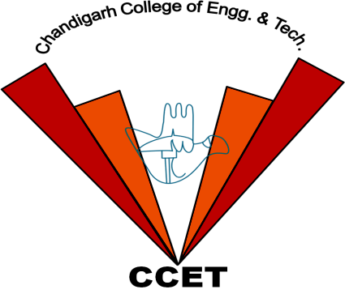

Bachelor of Engineering
IN COMPUTER SCIENCE AND ENGINEERING

3rd Sem

2024

Database System (Practical)
PRACTICAL-10
Subject Code: CS 352

Submitted by Submitted To

Sanatan Sharma Dr. Dheerendra Singh
(Roll no:CO23355) (Professor)

Date of assignment: Date of submission:
10th October, 2024 24th October, 2024

